University Events

Portal Overview

PRESENTED BY

K RISHIKA



University Events Portal Introduction



User Engagement

Facilitate active participation of students in

campus events.

Centralized Information

Consolidate all events information for ease of

access.

Event Promotions

Enhance visibility of events through targeted

marketing.

Registration System

Implement an online registration process for

event attendees.

Feedback Collection

Gather participant feedback to improve future

events.

Calendar Integration

Sync events with personal digital calendars for

convenience.



Overview of University Events

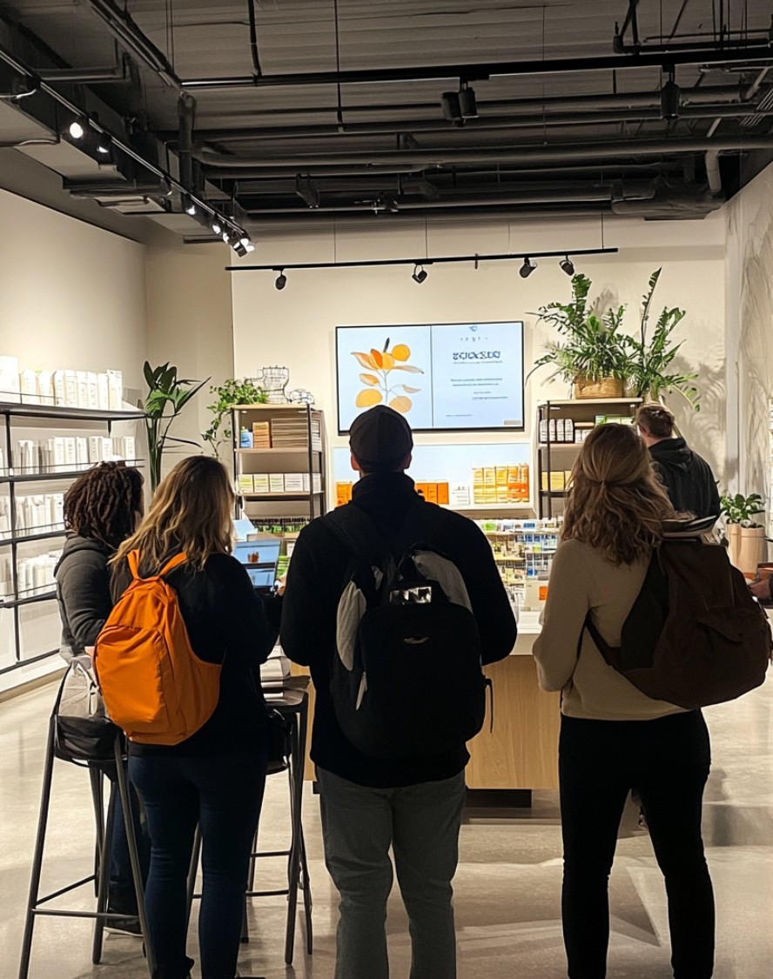

01

Event Management

Streamline planning and execution of university events through a centralized

platform that allows for efficient coordination and communication among various

stakeholders.

02

User Engagement

Enhance student participation and community engagement by providing a user-

friendly portal that showcases upcoming events, making it easy for students to

find and RSVP.

03

Resource Allocation

Optimize the utilization of university resources by tracking event attendance and

feedback, allowing for informed decisions on future events and investments.



Key Features of Events Portal



User-Friendly

Streamlined navigation and intuitive design for easy access to event information and

registration.

Real-Time Updates

Instant notifications for event changes, reminders, and new event announcements

accessible via the portal.

Customizable Filters

Allows users to sort and filter events by categories, date, and popularity for tailored

experiences.



System Requirements

Minimum

Recommended

Notes

Operating System

Windows 10

Windows 11

Supports 64-bit only

Browser Support

Chrome, Firefox

Latest Chrome, Firefox, Edge

Ensure latest updates installed

Database System

MySQL 5.7

MySQL 8.0 or higher

Check compatibility with features

Server Requirements

4

GB RAM

GB RAM

8

For optimal performance



User Management

User Management

Admins

Manage all user roles and

permissions.

Students

Register for events and update

profiles.

Faculty

Organize events and manage

registrations.

Guests

View events and register for

participation.



Event Management

E

Jan

Feb

Mar

Apr

May

Jun

Jul

Aug

Sep

Oct

Nov

Dec

This is a sample Gantt Chart. Please edit the timeframe above according to your schedule

Plan

Promote

Execute

Review



Participation System

01

Awareness

Students learn about events through

advertisements.

02

Interest

Students express interest in specific events and activities.

03

Registration

Students register for events that catch their attention.

04

Engagement

Students participate in various scheduled event sessions.

05

Feedback

Participants provide feedback after events are completed.

06

Involvement

Students get involved in organizing future events.



Notification System

01

Step 1

Users subscribe to receive notifications about upcoming events.

02

Step 2

Events are created and scheduled by the

university staff.

03

Step 3

Notifications are sent out based on user preferences and event

timing.

04

Step 4

Users receive notifications and can RSVP or get

more details.



Top Performer

Awarded to the student with the highest achievements in academics.

Outstanding Contribution

Recognizes individuals who significantly contribute to university activities.

Team Player

Honors students who actively participate in group initiatives.

Participation Award

Given to students who regularly engage in university events.

Honorable Mention

Acknowledges commendable efforts even if not

award-winning.

Rewards and Recognition



Sponsorship Features



Brand Exposure

Increase visibility through event

marketing and promotional materials.

Targeted Audience

Access to specific demographics

through event sponsorship packages.

Networking Opportunities

Facilitate connections with attendees

and other sponsors.

Program Integration

Incorporate logo on event materials and

digital platforms.

Community Engagement

Support local initiatives and enhance

brand reputation.

Post-Event Analytics

Receive detailed reports on engagement

metrics and sponsor impact.

Customized Packages

Offer tailored sponsorship levels based

on budget and needs.

Exclusive Perks

Provide sponsors with VIP access and

special event opportunities.



Technical Requirements

Frontend

Backend

Database

Hosting

Feature

HTML/CSS/JS

Node.js

MySQL

AWS

Technology

React.js

Express

PostgreSQL

Heroku

Requirements

Responsive Design

REST API

ORM

Cloud Storage

Notes

Accessibility

Scalability

Security

Backup



Frontend (React)



Utilize React for dynamic rendering of university events,

implement reusable components for event cards, manage state

with hooks for event listings, and ensure responsiveness to

provide a seamless user experience across various devices.



Backend (Node.js & Express)

API Setup

Create RESTful APIs for handling event data

seamlessly.

Database Integration

Utilize MongoDB for efficient data storage and

retrieval.

User Authentication

Implement JWT for secure user login and

registration.

Real-time Updates

Employ WebSockets for live event notifications

and interactions.

Middleware Usage

Apply middleware for error handling and request

validation.

Route Management

Organize routes for scalability and

maintainability in the codebase.

Deployment Strategies

Use Docker for containerization and easy

deployment of the application.



Database (MongoDB)



Data Storage

Efficiently store events data with flexible

document structure.

Scalability

Easily scalable to handle growing number

of event records.

Real-Time Access

Provides fast access to updated event

information seamlessly.

User Analytics

Track user interactions for insights on event

preferences.



DevOps & Deployment

D

Week 1

Week 2

Week 3

Week 4

Week 5

Week 6

Week 7

Week 8

Week 9

Week

10

Week

11

Week

12

This is a sample Gantt Chart. Please edit the timeframe above according to your schedule

Planning

Development

Testing

Deployment

Monitoring

Feedback



Success Stories and Case Studies



Problem Faced

Difficulties in managing event registrations and

attendance.



Solution Offered

Developed a centralized online university events portal.



Benefits

Improved user experience and increased event

participation.



Instructions to Change Color of Shapes

Some shapes in this deck need to be ungrouped to

change colors

Step 1:

Select the shape,

and right click on it

Step 2:

Select Group ->

Ungroup.

Step 3:

Once ungrouped,

you will be able to

change colors

using the “Format

Shape” option

